7 FREE
Soup-er Suppers!
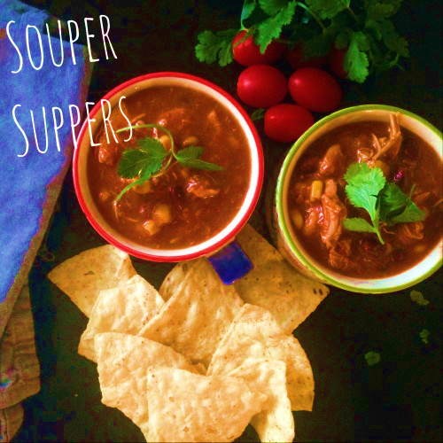
Looking for something
Spiritual to do
For lent??
Join
FOLLOWING CHRIST
for
7 Free Salad &
Soup-er Suppers!
You won’t regret enriching your Lenten experience by joining these 7 weekly gatherings. Enjoy Soup-er/Salad Suppers with dessert, dynamic teachings and music with group discussions. Sign up today as seating is limited!

Location: St. Leo the Great
Date: Thursdays, Feb 8-March 15
Time: Dinner starts at 6:15pm,
Lenten Evening ends at 8:30pm
Retreat Day: Sat. March 10

Name:_____________________________________________ Sex: M F
Email:_______________________________________
Phone: ______________________________________Text? Y N Address:_____________________________________________________

Return FOLLOWING CHRIST form to St. Leo the Great Parish Office or register on-line at www.stleothegreatamherst.com
Contact Dawn Iacono at 835-8905 x12 for more information

